Brooklyn torah gazette
For yom tov pesach 5783
Volume 7, Issue 30 (Whole Number 337) 15-22 Nissan 5783/ April 6-13, 2023
Printed L’illuy nishmas Nechama bas R’ Noach, a”h

For a free subscription, please forward your request to keren18@juno.com

Getting Ready for
Bedikas Chametz!

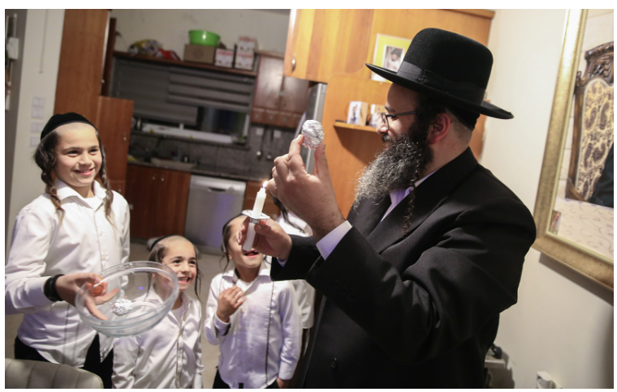
An ultra-Orthodox man holds a candle as he performs bedikus chamutz, a ritual in which he looks for remains of leaven after cleaning his home, on the night before the upcoming Passover holiday, in Safed, on March 25, 2021. (David Cohen/Flash90)

Getting Ready for
Pesach (Passover)
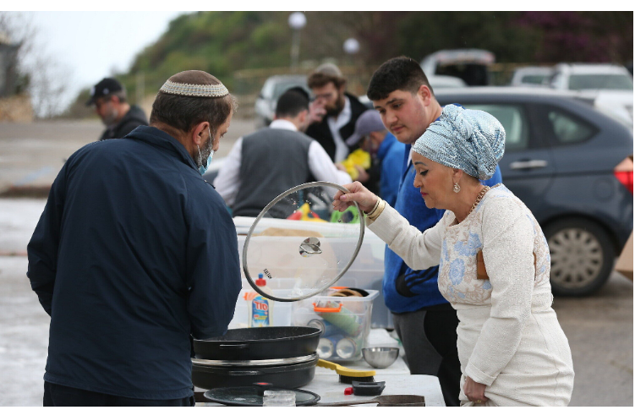
Orthodox Jews get their cooking pots dipped into hot water to rid any traces of leavening in preparation for the upcoming Jewish holiday of Passover, in Safed, March 25, 2021 (David Cohen/Flash90)
Pesah- Miracles Do Happen!
By Rabbi Joey Haber

As part of the introductory section of Maggid – the main part of the seder, during which we talk about Yetziat Mitzrayim – the Haggadah teaches us, וכל המרבה לספר ביציאת מצרים הרי זה משובח. This means that anyone who prolongs his discussion of Yetziat Mitzrayim is “praiseworthy.”
The commentators take note of the fact that the Haggadah does not say that this practice is משובח, but rather that the person himself is משובח.

When a person delves into the story of Yetziat Mitzrayim, when he speaks at length about the miracles Hashem performed for our ancestors, he becomes משובח – he is uplifted and elevated; his life becomes enhanced.
Why? Because in order to properly handle life, we need to believe in miracles.
In today’s world, there is so much anxiety, so much fear, so much negativity, and so much stress. People are worried about their livelihood, how they are going to pay their bills. People are worried about their children’s emotional, social, and educational development. People are worried about health issues. People are worried about when and whether their children will get married. People hear current events and are worried about the world.

Why We Rarely Talk About Miracles
There is so much worry, because all we talk about is the problems. We so rarely, if at all, talk about the miracles.
We have all experienced miracles firsthand. We have all had times when we were worried how something would work out, and somehow, it did. Whether it was a job, a business, an investment, a problem with a child, a child who needed a shidduch, a medical issue – we have all experienced miracles. Every single one of us, without any exception.
Yet, we still worry. We worry because we spend more time thinking and talking about the problems we face than we do about the problems which have been miraculously solved.
The experience of the seder is meant to remind us that miracles do happen. The more we talk about Yetziat Mitzrayim, of how Beneh Yisrael were in a hopeless, miserable situation and then suddenly emerged as a proud, free, wealthy nation – the more משובח we are, the happier and less anxious we will be, because we will live with the knowledge that miracles happen.

Hashem’s Greatness and Kindness
We spend a considerable amount of time in shul each morning reciting the daily Shaharit prayer. The prayer text we recite hardly makes any mention of problems. The berachot and Pesukeh De’zimra sections speak only about Hashem’s greatness and kindness, all the things He does for us and for the world. And even in the Amidah prayer, in which we ask for the things we need, we do not speak at length about our problems.
Rather, we ask Hashem to help us because we know that He helps. We say things like, “You grant wisdom, so please grant us wisdom; You heal, so please heal the sick; You’re a redeemer, so please redeem us.” Our prayers our hopeful and optimistic, expressing confidence, not fear and anxiety.
This is the mindset with which we should live our lives, and this is the mindset that the Pesach seder is meant to inspire.
The Torah emphasizes that our ancestors left Egypt בחודש האביב, in the springtime, when the weather conditions are perfect, neither too cold nor too warm. During the long, dark, cold winter months, it is hard to recognize that spring will arrive, that the sun will again shine and it will be warm and pleasant. Yetziat Mitzrayim occurred during the springtime because this is the lesson it teaches us – that spring does come, that the winter does not last forever, that our difficult problems somehow get solved.
No matter what we’re going through, whatever problem it is that we face, let us remember that “spring” will arrive, that redemption will come, that miracles do happen. The more we talk about the miracles that our ancestors experienced, and the miracles we ourselves have experienced, instead of talking about the problems, the more משובח we will be, and we will live with greater joy and optimism, each and every day.

Reprinted from the Pesah 5782 email of Rabbi David Bibi’s Shabbat Shalom from Cyberspace.

The Most Important
Thing You Need to Do
To Prepare for Pesach
By Rabbi Efrem Goldberg
-
Given the current price per pound, it sure doesn’t feel like Matzah is lechem oni, the bread of the poor person. Last year, 200,000 pounds of handmade shmurah matzah were baked and shipped from Ukraine to the United States, in addition to what is shipped to Europe and Israel. But, two hours before the last 20,000 pounds were loaded onto a ship in the port of Odessa, Russia invaded, and the matzahs have been stuck in limbo since. Partially due to Putin, but also because of general supply chain issues and increased gas and shipping prices, the cost of matzah—and seemingly everything else for Pesach—is incredibly high.
More people than I can remember in any previous year have shared with me that they simply don’t know how they will afford Pesach this year. Some have explicitly said that when they stand in the supermarkets and look at the prices, they calculate that they can buy matzah or meat but not both.

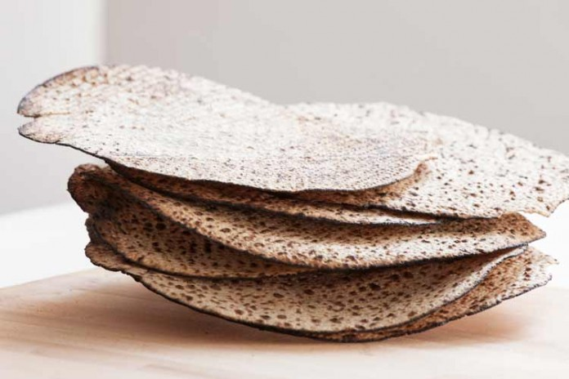
Shmura Matzah

The bad news is that the prices this year are affecting more people than ever.
The good news is that there is a solution to enable everyone to have a beautiful and simcha-filled Pesach.
Since the creation of the luxury Pesach program, rabbis have been railing against them for their excessiveness, extravagance, and the forfeiting of many of the traditions involved in preparing and experiencing Pesach. Ironically, many of those same rabbis have later “eaten their words” and accepted invitations to serve as scholars in residence, bringing their families to the very type of five-star experience they had long condemned.
But internal contradictions aside, there is a more fundamental reason not to rail against such programs: there is nothing inherently wrong with them. True, kashrus can be complicated at these programs, and yes, not all the environments and activities at every program are appropriate for Yom Tov, or ever. But these are not intrinsic or inherent deficiencies and just mean that one must choose the program carefully.
The Practical Need for a Pesach Program
Baruch Hashem, there are many large Jewish families that, for practical reasons, simply cannot experience a Yom Tov together if they are not at a program. In addition, there are those who are unable to make Pesach for themselves, don’t have family to go to, and rely on a program in order to experience a proper Pesach. And then there are those that can simply afford to experience the luxury of a Pesach program and, given that they are often generous with their support of charitable and communal institutions, why shouldn’t they?
But there is a caveat. There is no Jewish holiday and no Jewish experience that more divides the “haves” from the “have-nots” than Pesach. The contrast between those experiencing Pesach with endless menu options, midnight BBQ’s, quinoa sushi stations, and round-the-clock tea rooms, and those who literally don’t know how they will buy matzah or wine, let alone meat, is startling and staggering.

Exposed to Both Extremes
As a community Rabbi, I am exposed to both extremes. When arranging for the sale of chametz, I like to ask what people’s Pesach plans are. Often, I find myself meeting with someone who, with joy and excitement on his face and great anticipation in his voice, will describe the latest exotic location of the program he is attending this year or the newest amenity or entertainment being offered.
Literally moments later, someone will answer the same question with a tear in his eye and worry on his face and say I have no idea how I am going to afford matzah and wine this year because I am barely covering my bills day-to-day without these added expenses.

The Obligation to Help the Destitute and Poor
The Rambam writes (Hilchos Yom Tov 6:18):
When a person eats and drinks [in celebration of a holiday], he is obligated to feed converts, orphans, widows, and others who are destitute and poor. In contrast, a person who locks the gates of his courtyard and eats and drinks with his children and his wife, without feeding the poor and the embittered, is [not indulging in] rejoicing associated with a mitzvah, but rather in simchas kreiso, the rejoicing of his gut.
Though the Rambam is speaking of every holiday, there is a special practice of providing for others specifically before Pesach. The Rama (O.C. 429:1) quotes from the Talmud Yerushalmi, (Bava Basra 1:4) which states that residents of a city should give wheat or flour for matzah to those in their city in need. This is known as kimcha d’pischa, flour for Pesach, or maos chittim, money for wheat.
And yet, even with the widespread practice of giving to maos chittim, there remain far too many who struggle to keep up with the exorbitant cost of making even a basic, no-frills Pesach and are left having to cut back and sacrifice in other areas just to get through what should be a joyous holiday season.
And herein lies the caveat. There is nothing wrong with enjoying and indulging in the luxuries a Pesach program provides, or with making a beautiful, elegant Pesach at home, for that matter, so long as everyone from your community can afford to have the basic necessities. There is no set amount mandated for maos chittim, but I humbly submit the following proposal:

How to Base Hom Much
Maos Chittim One Should Give
Just as with tzedaka, where we are instructed to give a percentage of our income, our maos chittim should similarly be calculated based on how much we spend on ourselves for Pesach. If all of those who attend Pesach programs gave proportionally to maos chittim, we could ensure that all members of our communities have what they need for Pesach without having to compromise or make trade-offs with other basic necessities. And in the spirit of Pesach, v’chol hamarbeh, harei zeh m’shubach – anyone who can and does give more is certainly worthy of praise.
True, many Pesach programs run fundraisers over Yom Tov for all kinds of worthwhile causes, but only a fraction of people participate, and by that point it is too late to help serve this particular, urgent need. It is instructive that the practice of giving to maos chittim is quoted in the context of the law that mandates that we begin preparations thirty days before Pesach.

Unimaginable Anxiety, Stress and Worry
Not knowing how one will afford to make Pesach for their family brings unimaginable anxiety, stress, and worry that compound an already difficult situation. The sooner people can be provided for and have the security that their family will indeed enjoy the amenities of Pesach, the less they will worry and fear.
A woman once approached the Beis HaLevi, Rav Yosef Dov Soloveitchik of Brisk, a few days before Pesach with a strange question. She wanted to know whether one could use milk instead of wine for the four cups of the Seder. The Rav asked her if she was ill, to which she replied that she was perfectly healthy. He then responded by giving her a large sum of money. After she left, the Rebbetzin asked her husband why he had given the woman so much money, when wine costs much less. He responded, “If she is asking about drinking milk at the Seder, it is obvious that she has no meat for Pesach, so I gave her enough to buy both wine and meat for the entire holiday.”
When we sit down for our beautiful, bountiful seder with our loved ones, our simchas yom tov should be enhanced by the knowledge that we have done what we can to ensure that none of our brothers and sisters is sitting down to a bare table where real tears substitute for salt water.
We are already well within thirty days of Pesach. Whether you are going to a Pesach program or making Pesach at home, please don’t wait to make sure that everyone can enjoy Pesach. When you are deciding how much to give, please consider what you are spending on your own Pesach for fine wines, delicious meats, and pounds of handmade shmurah matzah, and give commensurately to ensure a beautiful Pesach for all your neighbors as well. Knowing that nobody in your neighborhood is struggling for Pesach will be more delicious, intoxicating satisfying, and simcha-generating than anything on your table.
Reprinted from the April 12, 2022/Pesach 5782 website of the Jewish Press. Reposted from Rabbi Efrem Goldberg’s website. Rabbi Efrem Goldberg is the senior rabbi of the Boca Raton Synagogue in Boca Raton, Florida, the largest Orthodox Synagogue in the Southeast United States.

How a Jewish Woman in Florida Learned to Be Free in Prison
By Kayla Rosen

Recently released and looking forward to celebrating Passover, the Season of our Freedom, Sara reflects on her incarceration as a time of growth and resilience, when she was able to find a deeper connection to her Jewish roots.

On her first day in the South Florida correctional facility in 2022, Sara remembers thinking to herself, “welcome to the jungle.” As a naturally quiet and private person, it was hard for her to adjust to the chaos of jail life. And yet, she says, in a place of such darkness and isolation, she discovered through a Chabad-Lubavitch rabbi a deeper light that carried her through imprisonment.
Recently released and looking forward to celebrating Passover, the Season of our Freedom, Sara reflects on her incarceration as a time of growth and resilience, when she was able to find a deeper connection to her Jewish roots.
“I grew up in a traditional Jewish home. I spent my childhood learning in Jewish day schools, and we were part of the Jewish community.” Sara shares with Chabad.org. “I had a solid Jewish background. By the time I entered jail, I wasn’t as observant as I once was, but my Jewish roots ran deep and the connection never left me.”
Photo by Joseph Sohm

Early on in her jail sentence, Sara remembers seeing a rabbi walk into the main room. He was wearing a baseball cap, but she could see his tzitzit peeking out from under his jacket as he stood talking to two other young women. Sara asked a nearby guard permission to speak with the rabbi, but she was immediately shushed and shooed away. Thankfully, the rabbi, Rabbi Menachem Katz, director of program outreach at the Aleph Institute, watched this whole interaction and approached Sara himself.
As Sara sees it, it was as if “G-d had walked into the very room,” bringing a light to Sara that would be her lifeline throughout the year. She didn’t realize it at first, but Judaism would become her rock while in jail. The holidays and the little Shabbat practices that she managed to keep were what kept her grounded, she says. She looked forward to each and every Torah book or magazine that came her way, and the occasional prayer services and learning sessions that Aleph succeeded in organizing in the facility.
The Aleph Institute, founded in 1981 under the direction of the Lubavitcher Rebbe—Rabbi Menachem M Schneerson, of righteous memory—is a Florida-based organization geared towards providing for the spiritual and physical needs of Jewish soldiers and prisoners, and their families, throughout the United States.

A Jewish Lifeline
“Being Jewish is what carried me throughout my time in jail. I wouldn’t have survived without it,” says Sara.
Sara was one of three Jewish women in her facility, and the most knowledgeable about Judaism. Gradually, with the rabbi’s encouragement, she became a kind of mentor to these two young women, leading study sessions and makeshift prayer services. On Friday nights, Sara would find paper cups and draw little flames on them, the closest she and her fellow inmates could get to Shabbat candles.
Sara vividly remembers one conversation she had with Katz, as it continues to be one that sits close to her heart. “He looked at me and said, ‘What brought you here is not the reason you are here. You have an opportunity to inspire these two Jewish women and really be there for them.’ ”
She recalls at that moment, “I knew my mission. I would bring light wherever I could.”
“I taught these women the Shema prayer,” Sara shares, emotion in her voice “and would go over it with them again and again. If they remembered one thing, I wanted it to be the Shema.”

Hearing Shofar in a Prison Sick Bed
Last fall, when Sara contracted Covid, which was surging through the jail, she was moved to a different area of the facility, separated from her two Jewish companions. With Aleph’s help, she was ultimately moved back and able to continue supporting the other women.
Even during the pandemic, while many other services in jail were put on pause and visitations dwindled to almost nothing, the rabbi continued to show up, a light in the lonely darkness. While sick and weak with Covid, and in strict quarantine, Sara remembers waking up to Katz with a shofar in hand, who braved the lockdown to make sure that one Jew could hear the blast before Rosh Hashanah.
There wasn’t one holiday that they didn’t show up for, recalls Sara. Whether it was special kosher food, prayerbooks, or proper reading material and online classes, the Jewish inmates were supported in every way.

A Very Special Passover
But for Sara, on the very holiday that commemorates her nation’s freedom, Passover in jail stands out in her mind.
“We had to beg and plead with the officers to let us make a small Seder in a private room used for visits with attorneys,” she explains. “We hadn’t received any Passover food or resources at that point, so I was prepared to have a makeshift seder of plastic and paper. But just as we were sitting down, a guard came in with a bag filled with everything our Seder would need.”
From handmade shmurah matzah to maror, from fresh gefilte fish to hard-boiled eggs, their Seder plate was not only complete but beautiful as well, as they read through the Haggadah in a small backroom of a Florida jail facility. Sara sat with the other Jewish women, knowing intimately what their forefathers went through, as they themselves had lost their freedom. Yet Sara says she understood that for them, they were not in prison because they were Jewish. On the contrary, their Jewish identity in prison was a freedom she says she will continue to cherish for the rest of her life.
Since her release, Sara continues to study Torah and celebrate Shabbat and Jewish holidays with family and friends. She even hopes to volunteer for the Aleph Institute one day and give back to the organization that brought her so much strength in a time of such darkness.
As she now continues to care full-time for her aging mother, a Holocaust survivor, Sara reflects on the meaning of freedom with Passover right around the corner.
“Freedom is our ability to choose to live a life that we desire, and thank G-d, I now have the opportunity to do just that.” This year, Sara will be celebrating her own freedom alongside family and friends in the warmth of her own home.

Reprinted from the March 23, 2023 website of Chabad.Org website.

Matzah: Bread of Affliction, Bread of Liberation
By Jeff Jacoby

Symbol of slavery or freedom? Exploring the seeming contradictory meanings of this ancient bread.
Seventy-five years ago this month, the Anglo-American Committee of Inquiry convened a hearing in Jerusalem. Its lead-off witness was David Ben Gurion, who was then the foremost leader of the Jewish community in Palestine.
The task of the committee was to report on political and social conditions in Palestine, which in March 1946 was still under British rule. The future of Palestine was an issue on which the two allies did not see eye to eye. American public opinion supported Jewish aspirations to a measure of sovereignty in the Holy Land, and President Truman was pushing the British government to allow 100,000 survivors of the recently ended Holocaust to immigrate into Palestine.
But Britain opposed Jewish immigration. Hostility to Jews was rampant throughout the Arab world, where the British Empire had extensive commercial and diplomatic interests, and Whitehall was unwilling to get on the wrong side of Arab opinion.

The British Government Reversed its
Balfour Declaration Commitment
Though Britain’s historic Balfour Declaration of 1917 had famously endorsed “the establishment in Palestine of a national home for the Jewish people,” the government had reversed that position in 1939, barring most Jews from entering the land and thus choking off an escape route from Europe just as the Nazi genocide was getting underway.
Today the Anglo-American Committee is largely forgotten. Its findings became moot in November 1947, when the United Nations recommended that Palestine be partitioned into two states, one Jewish and one Arab. Nonetheless, Ben Gurion's heartfelt testimony making the case for Jewish sovereignty in the Jewish homeland is still worth reading, as I remarked in a column a few years ago:
In one memorable passage, the man who would two years later become Israel's first prime minister addressed the astonishing longevity of the Jews' love affair with Zion.
“More than 300 years ago a ship by the name of the Mayflower left Plymouth for the New World,” Ben Gurion told the committee. “It was a great event in American and English history. I wonder how many Englishmen or how many Americans know exactly the date when that ship left Plymouth, how many people were on the ship, and what was the kind of bread that people ate when they left Plymouth.”

The Knowledge of Countless Jews
Few Americans, of course, know any of those minutiae. But countless Jews, Ben Gurion went on, know the details of a far older journey.
“More than 3,300 years ago the Jews left Egypt. It was more than 3,000 years ago – yet every Jew in the world knows exactly the date when we left. It was on the 15th of Nisan. The bread they ate was matzot. [To this day] Jews throughout the world on the 15th of Nisan eat the same matzot – in America, in Russia – and tell the story of the exile from Egypt. [They] tell what happened, all the sufferings that happened to the Jews since they went into exile. They finish [their retelling with] these two sentences: ‘This year we are slaves; next year we will be free. This year we are here; next year we will be in Zion, the land of Israel.’”
The 15th of Nisan returns once again this coming weekend. And as they have for 33 centuries, Jews the world over will once again sit down to the Passover Seder – the ritual feast and storytelling that marks the start of the festival – and once again eat matzah (plural: matzot), the unleavened flatbread of the ancient Middle East.

More to a Seder than Eating Matzah
Of course, there is much more to a Seder than eating matzah. The ceremonial meal is replete with customs and rituals: the bitter herbs, the four cups of wine, the recounting of the Exodus, the “Four Questions” asked by the youngest at the table, the tears-like salt water into which a vegetable is dipped, the hiding of the afikoman, the Cup of Elijah, and reclining as a gesture of freedom.
But there is no question that matzah is the most celebrated symbol associated with Passover, so much so that the Hebrew Bible itself routinely refers to the holiday not as “Passover” but as chag ha-matzot – the Festival of Unleavened Bread.
Matzah is the simplest of prepared foods, made from nothing but flour and water, baked before it has a chance to rise. Yet its meanings are rich and seemingly contradictory.
On the one hand, it is the “bread of affliction.” That is how it is described in Deuteronomy , and how it is spoken of near the very start of the Seder, when the matzah is uncovered and those around the table announce: “This is the bread of affliction that our fathers ate in the land of Egypt. Let all who are hungry come and eat.”

The Challenge of Digesting Matzah
As a child I was taught – and innumerable generations of Jewish children were taught before me – that we eat matzah on Passover to recall the slave rations of our ancestors. Matzah is hard, meager, slow to digest. If it doesn’t taste good, at least it doesn’t go bad. During the years of bondage in Egypt, matzah was the daily reminder to the Israelites of their lowly status, the crust that symbolized the degradation and misery of their existence.
That is how the Seder begins: by harking back to the “bread of affliction.” Yet before anyone in the room will have a chance to eat matzah – to say nothing of the lavish meal to follow – its meaning will have changed. In a key passage, the Haggadah (the text recited during the Seder) quotes a different biblical passage to explain the meaning of the unleavened bread at the table:
This matzah that we eat – what does it signify? It signifies that our forefathers’ dough did not have time to rise before [G-d] redeemed them. As it says [Exodus 12:39]: “They baked the dough which they had brought out of Egypt into sheets of matzah, because it had not leavened; for they had been driven out of Egypt and could not delay, nor had they prepared for themselves any other provisions.”
All at once, matzah has ceased to be the bread of affliction, and has become the bread of freedom – not the bare-bones food that sustained the Israelites during the years of hard labor, but the bare-bones food they prepared as they stood on the cusp of liberty. All their lives they had eaten matzah under the severe constraints of servitude, denied even the time to bake a proper loaf of bread.
Now, as they rushed to leave Egypt and all its cruelties behind, they were again in too much of a hurry to bake a proper loaf of bread. Once again they prepared the hard dry flatbread they knew so well. But this time it epitomized not the wretchedness of being downtrodden, but the eager anticipation of people whose lives were suddenly filled with promise and possibility.
“Freedom is in the psyche, not in the bread,” writes Irving Greenberg in The Jewish Way, his engrossing book on Judaism and the Jewish calendar.
The difference between slavery and freedom is not that slaves endure hard conditions while free people enjoy ease. The bread remained equally hard in both states, but the psychology of the Israelites shifted totally. When the hard crust was given to them by tyrannical masters, the matzah they ate in passivity was the bread of slavery. But when the Jews willingly went from green fertile deltas into the desert because they were determined to be free, when they refused to delay freedom and opted to eat unleavened bread rather than wait for it to rise, the hard crust became the bread of freedom. Out of fear and lack of responsibility, the slave accommodates to ill treatment. Out of dignity and determination to live free, the individual will shoulder any burden.

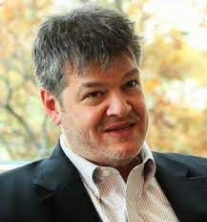
Jeff Jacoby

This article was excerpted from the aish.com website. It was originally appeared in Jeff Jacoby's weekly newsletter, Arguable, which is sponsored by the Boston Globe. Photo credit: Todd Rosenblatt

